Experiment 1
Investigating the Significance of Characteristic Impedance (Zo) and Propagation Constant (γ) of a Transmission Line Using the Following Parameters:
Resistance (R)
Capacitance (C)
Inductance (L)
Conductance (G)
Test case-1
Code-
clear;
clc;
R=10;
L=0.003;
f=2*10^3;
G=4*(10^-6);
C=8*(10^-6);
w=2*%pi*f;
Z=R+(%i*w*L);
Y=G+(%i*w*C);
Zo=sqrt(Z/Y);
C1=round(real(Zo));
D1=round(imag(Zo));
printf("Zo = %f + j(%f) ohms\n",C1,D1);
P=sqrt(Z*Y);
a=real(P);
a1=round(a*10000)/10000;
printf("Attenuation constant a = %f neper/km\n",a1);
b=imag(P);
b1=round(b*10000)/10000;
printf("Phase constant b = %f radians/km\n",b1);

Output: Practical Result
Characteristics Impedance | Attenuation | Phase constant
20.00+j(-3) ohms | 0.2460 Neper/km | 1.96350 rad/km
Theoretical Result-
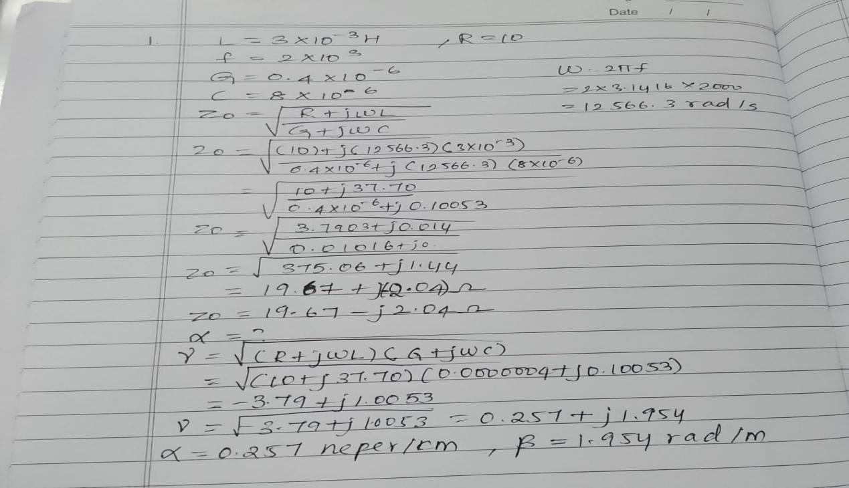
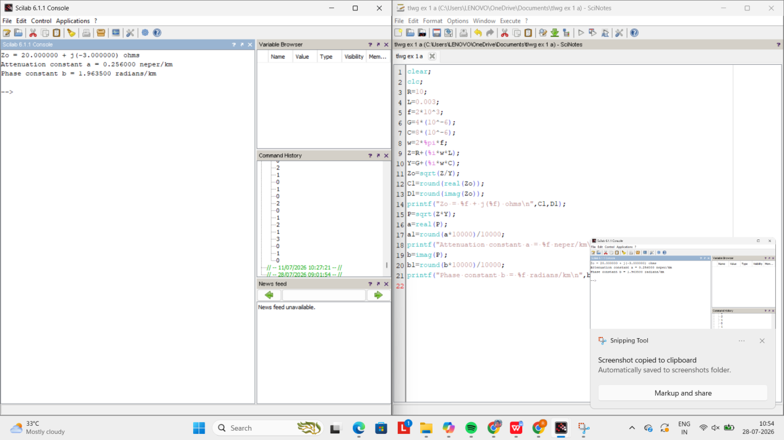

Test Case 2:
Code-
clear;
clc;
R=10;
L=0.003;
f=2*10^3;
G=4*(10^-6);
C=8*(10^-6);
w=2*%pi*f;
Z=R+(%i*w*L);
Y=G+(%i*w*C);
Zo=sqrt(Z/Y);
C1=round(real(Zo));
D1=round(imag(Zo));
printf("Zo = %f + j(%f) ohms\n",C1,D1);
P=sqrt(Z*Y);
a=real(P);
a1=round(a*10000)/10000;
printf("Attenuation constant a = %f neper/km\n",a1);
b=imag(P);
b1=round(b*10000)/10000;
printf("Phase constant b = %f radians/km\n",b1);

Output- Simulation Result-
Variable R
Input(R) | Z0 | Attenuation | Phase constant
20 | 20+j(-5) ohms | 0.50020 neper/km | 2.010 rad/km
30 | 21+j(-7) ohms | 0.72580 neper/km | 2.077 rad/km

Theoretical Result-
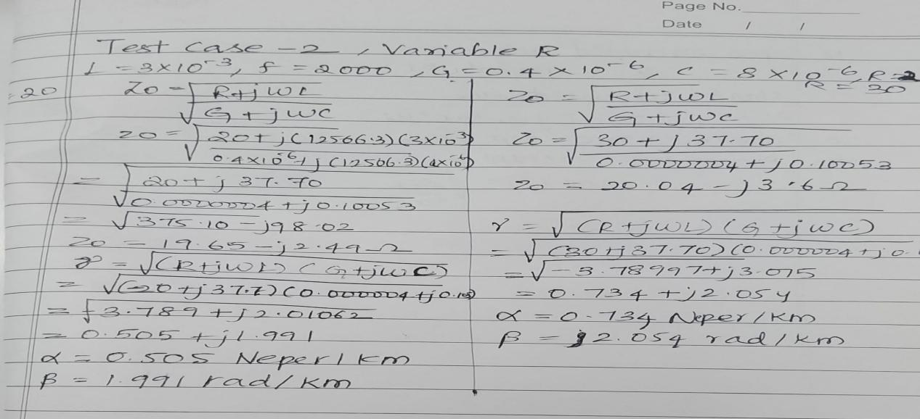
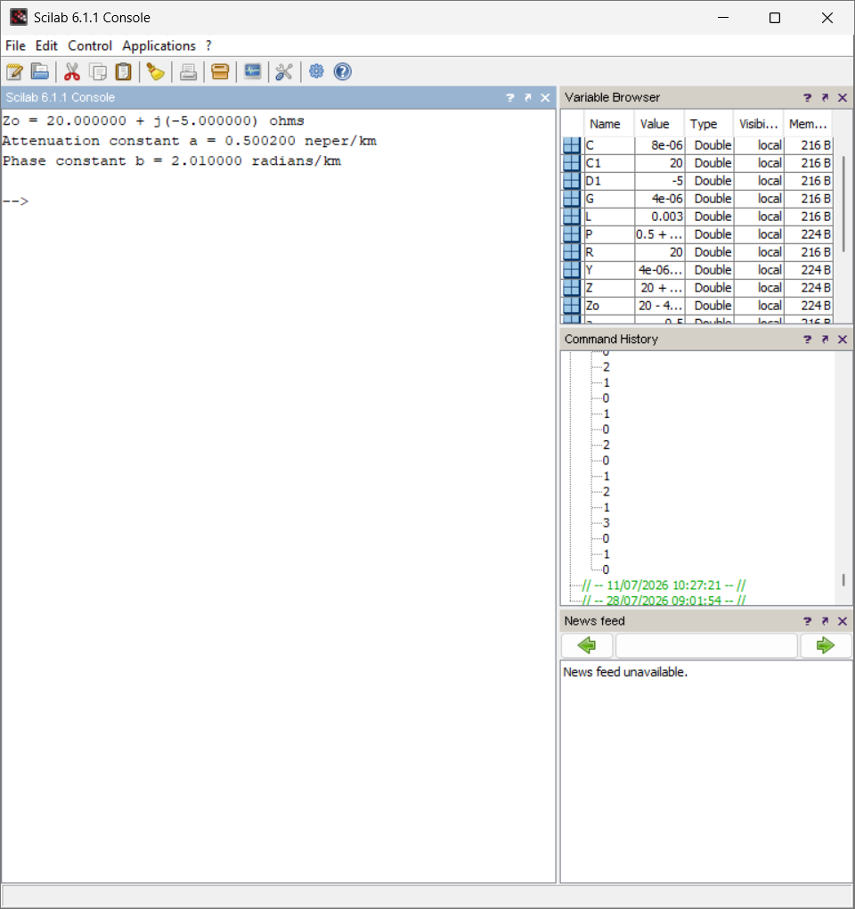

Output- Simulation Result-
Variable l
Input(l) | Z0 | Attenuation | Phase constant
0.005 | 26+j(-6) ohms | 0.5845 neper/km | 2.58rad/km
0.006 | 28+j(-5) ohms | 0.537 neper/km | 2.805rad/km

Theoretical Result-
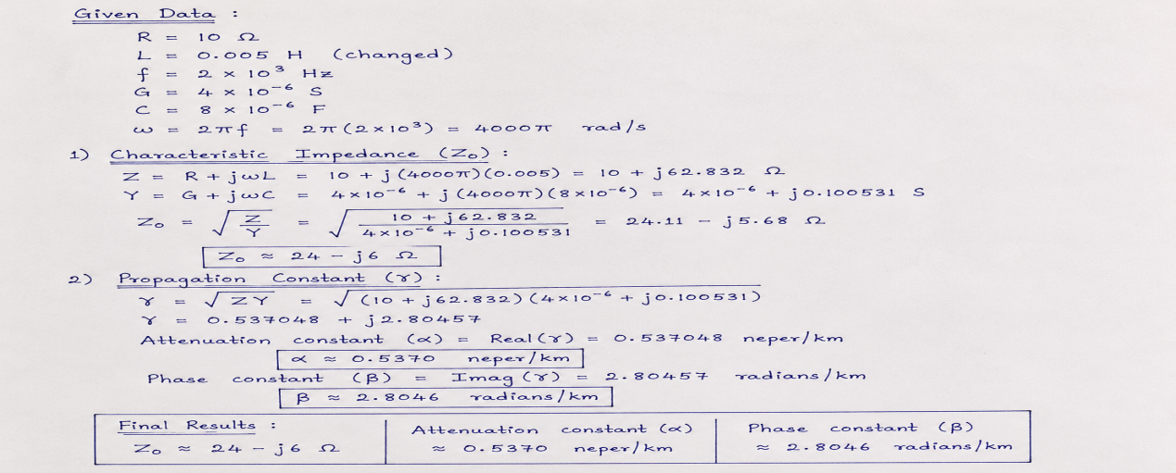

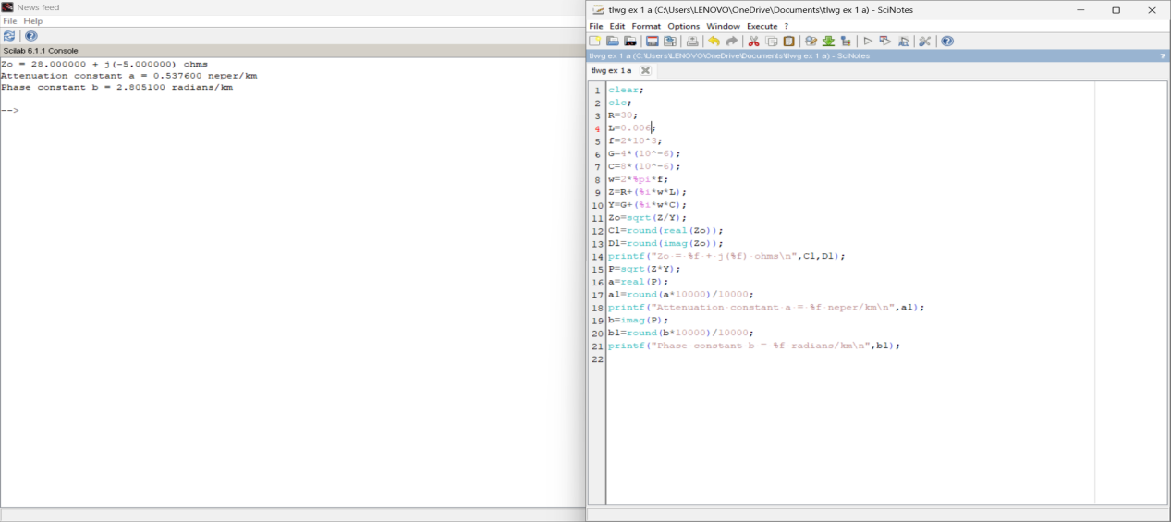

Test Case 3:
Code-
clear;
clc;
R=10;
L=0.003;
f=2*10^3;
G=4*(10^-6);
C=8*(10^-6);
w=2*%pi*f;
Z=R+(%i*w*L);
Y=G+(%i*w*C);
Zo=sqrt(Z/Y);
C1=round(real(Zo));
D1=round(imag(Zo));
printf("Zo = %f + j(%f) ohms\n",C1,D1);
P=sqrt(Z*Y);
a=real(P);
a1=round(a*10000)/10000;
printf("Attenuation constant a = %f neper/km\n",a1);
b=imag(P);
b1=round(b*10000)/10000;
printf("Phase constant b = %f radians/km\n",b1);

Output- Simulation Result-
Variable f
Input(l) | Z0 | Attenuation | Phase constant
3kHz | 28+j(-4) ohms | 0.54310 neper/km | 0.543rad/km
5kHz | 27+j(-2) ohms | 0.546 neper/km | 6.90rad/km

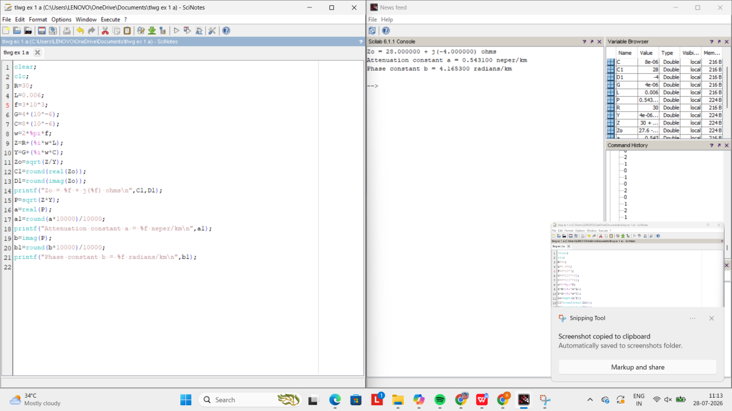
Output- Simulation Result-
Variable c
Input(c) | Z0 | Attenuation | Phase constant
9 micro farad | 26+j(-2) ohms | 0.579 neper/km | 7.323rad/km
11 micro farad | 23+j(-2) ohms | 0.6403 neper/km | 8.096rad/km
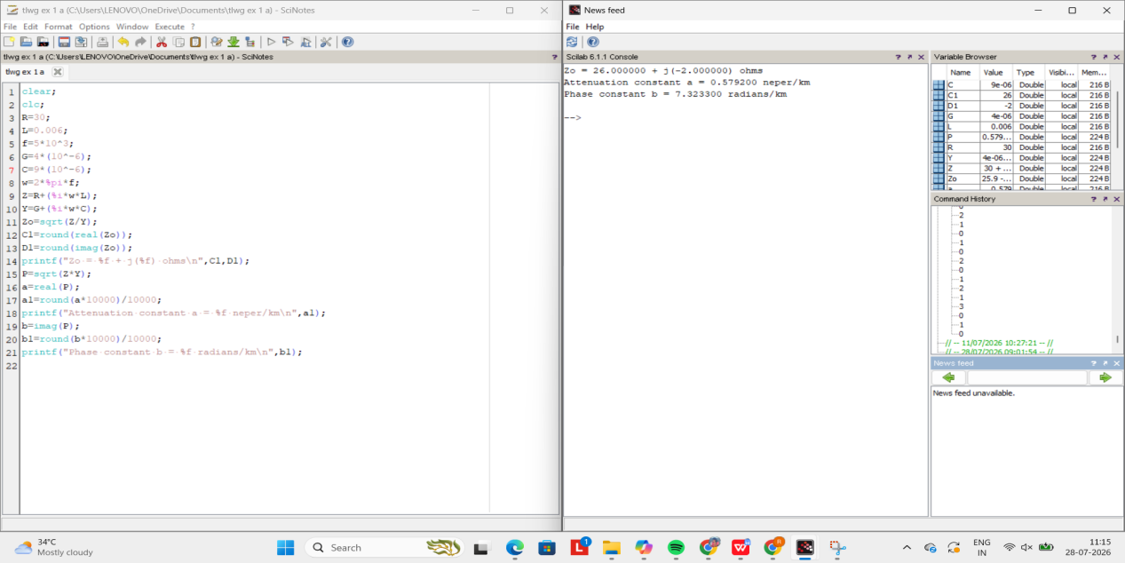

Theoretical Result-
